BISIG - Bidirectional Interface for Sign Intelligence & Gestures: Bridging FSL and Spoken Language via Pose-Based Transformers

A Thesis
Presented to the Faculty of Undergraduate School
Polytechnic University of the Philippines
Parañaque Campus

In Partial Fulfillments of the Requirements for the Degree
in Bachelor of Science in Information Technology

By

Azuela Benz Robinson L.
Bughaw, Karl Benjamin R.
Habitan, Suzanne Hyacinth T.
Sanchez, John Lennon B.

ACKNOWLEDGEMENT
The researchers would like to express their deepest gratitude to Almighty God for His guidance, wisdom, strength, and protection throughout the completion of this study. His grace gave the researchers the courage to continue despite the challenges, pressure, and responsibilities encountered during the research and development process.
The researchers would also like to extend their heartfelt gratitude and appreciation to their families and friends for their constant support, love, patience, encouragement, motivation, and understanding. They served as a source of inspiration, especially during times of exhaustion, uncertainty, and difficulty.
Sincere gratitude is also given to our adviser, Mr. Michael Piga, for the valuable guidance, constructive feedback, patience, encouragement, and the back and forth consultation throughout the development of this study. Mr. Piga’s recommendations and feedback contributed a lot to the improvement of this study’s direction, quality, and clarity.
The researchers would also like to thank our instructor, Mr. Jefferson Costales, for providing the knowledge, instructions, and academic foundation necessary to complete this paper. The lessons, reminders, and requirements given throughout the course helped the researchers understand the importance of proper research, system development, and documentation.
The researchers would also like to acknowledge the Polytechnic University of the Philippines - Paranaque City Campus for providing an academic environment that encourages innovation, discipline, and continuous learning.
Lastly, the researchers would like to acknowledge themselves for their perseverance, teamwork, patience, and commitment in completing this study while balancing both work and academic responsibilities. As working students, it was never easy managing time, deadlines, system development, and personal obligations; however, through determination and cooperation, the researchers were able to overcome these challenges and complete this study successfully.
To everyone who contributed, supported, and inspired the completion of this research, the researchers sincerely express their deepest gratitude.

EXECUTIVE SUMMARY
This study, entitled “BISIG - Bidirectional Interface for Sign Intelligence & Gestures: Bridging FSL and Spoken Language via Pose-Based Transformers,” focuses on the development of an intelligent, bidirectional translation platform designed to help the Filipino deaf and hard-of-hearing community. In the Philippines, an estimated 1.53 million people have a hearing disability, representing a significant portion of the population for whom communication can be a daily challenge. While the field of sign language recognition has advanced, there remains a profound communication gap with the wider hearing community due to the lack of accessible, real-time translation systems localized for the Filipino context.
The study addresses key challenges in sign language translation, including the separation of recognition (signed-to-spoken) and production (spoken-to-signed) systems in existing work, and the high computational cost and latency that prevent real-time deployment on standard consumer devices. By adapting and fine-tuning models originally trained on American Sign Language (ASL) with localized Filipino Sign Language (FSL) datasets, the system bridges the gap between ASL-based pre-training and FSL-specific vocabulary.
BISIG is a web-based real-time bidirectional translation platform that consists of a React frontend, a FastAPI translation backend, a Go unified gateway, and a Node.js Express authentication server. The spoken-to-signed production pipeline converts spoken or written text into skeletal sign coordinates and renders a 3D avatar in real-time using Three.js with a 20-frame linear blending algorithm for smooth transitions. The signed-to-spoken recognition pipeline captures a user’s FSL video feed, extracts skeletal landmarks locally via MediaPipe, and streams coordinate sequences to a Vision-Language Transformer model (Qwen2-VL) over WebSockets to return translated text.
The study uses the Design and Development Research (DDR) approach, supported by the Iterative Prototyping Model (IPM), to guide the design, development, testing, and refinement of the system. It also uses the Technology Acceptance Model (TAM) to evaluate the platform in terms of perceived usefulness, perceived ease of use, user satisfaction, and system acceptance. The system will be evaluated by selected deaf individuals, sign language interpreters, and hearing users to measure performance targets including a Word Error Rate (WER) under 10%, user-rated clarity scores above 4.0 on a 5-point Likert scale, and end-to-end latency below 500ms.
Overall, BISIG is developed as a practical, accessible, and high-performance translation tool for the Filipino deaf community. By combining pose estimation, frontier multimodal transformers, and real-time avatar animation in a standard web browser, the platform aims to break communication barriers, support educational and professional inclusion, and promote reduced inequalities in access to digital and social services in the Philippines.

TABLE OF CONTENTS
- The Problem and Its Setting
1.1 Introduction 6
1.2 Statement of the Problem and Research Questions 7
1.3 Significance of the Study 8
1.4 Theoretical Framework 9
1.5 Conceptual Framework 10
1.6 Hypothesis 10
1.7 Scope and Limitations of the Study 18
1.8 Definition of Terms 20
- Review of Related Literature and Studies
2.1 The Evolution of Sign Language Translation Systems 20
2.2 The Rise of Transformer Models in Language and Vision 22
2.3 Real-Time Pose Estimation as a Foundational Layer 23
2.4 Web Technologies for Accessible and Scalable Deployment 23
2.5 Local Studies and Developments in FSL Technology 24
2.6 The Need for Localized FSL Resources and Transfer Learning 25
2.7 Synthesis of Review of Related Literature and Studies 26
- Research Methodology
3.1 The Design and Development Research (DDR) Framework 28
3.2 Development Methodology: The Iterative Prototyping Model (IPM) 30
3.3 Population and Sample Size 32
3.4 Sampling Technique 32
3.5 Research Approach: A Mixed-Methods Strategy 33
3.6 Data Gathering Procedure 33
3.6 Statistical Treatment of Data 35

CHAPTER 1

THE PROBLEM AND ITS SETTING

Introduction
In the Philippines, an estimated 1.53 million people have a hearing disability (Philippine Statistics Authority, 2023), representing a significant portion of the population for whom communication can be a daily challenge. For many, Filipino Sign Language (FSL) is their primary language, yet there remains a profound communication gap with the wider hearing community.
Communication is a fundamental human right, yet a significant barrier often exists for the Filipino deaf and hard-of-hearing community. The vast majority of the hearing population does not understand sign language, creating a communication gap that can lead to social exclusion and limited access to education, services, and social opportunities. This project is significant because it addresses not only this linguistic challenge but also the socioeconomic barriers to accessible communication.
While the field of sign language recognition has advanced due to large-scale datasets like WLASL (Word-Level American Sign Language) (Li, et al., 2020), there is a pressing need for a solution localized for the Filipino context. To address this, our project will primarily focus on Filipino Sign Language (FSL). We propose to leverage the foundational architecture of models trained on ASL by adapting and fine-tuning them with a dedicated FSL dataset, such as the one available on Kaggle (Porton, 2021), acknowledging the linguistic similarities between many signs to accelerate development.
A critical research gap persists, as most existing systems focus on either recognition (signed-to-spoken) or production (spoken-to-signed). Very few integrate both into a single, cohesive, and publicly accessible platform. This study addresses the need for a holistic solution by proposing an integrated, real-time, bidirectional translation system designed for maximum accessibility. By leveraging modern, universally available web technologies, the proposed system aims to create a more inclusive environment where communication is seamless and independent.
In doing so, the project directly aligns with several of the United Nations Sustainable Development Goals (SDGs). By aiming to reduce a profound inequality in access to information and services, it supports SDG 10 (Reduced Inequalities) and upholds communication as a fundamental human right, promoting SDG 16 (Peace, Justice, and Strong Institutions). The system is also positioned to contribute to SDG 4 (Quality Education) and SDG 8 (Decent Work and Economic Growth) by empowering deaf individuals to participate more fully in mainstream educational and professional environments. This improved access and inclusion directly fosters SDG 3 (Good Health and Well-Being). Finally, as an innovation in assistive technology, the project embodies the principles of SDG 9 (Industry, Innovation, and Infrastructure) by contributing to a more inclusive and resilient communication infrastructure.

Statement of the Problem and Research Questions
This study aims to address several critical issues related to communication accessibility for the Filipino deaf community. These issues have been distilled into the following primary research questions:
- Localization and Adaptation: How can a large-scale sign language recognition model, originally trained on American Sign Language (ASL), be effectively adapted and fine-tuned to achieve high accuracy for Filipino Sign Language (FSL)?
- System Architecture: What is an optimal full-stack architecture for a real-time, bidirectional sign language translation system that remains accessible on standard web and mobile browsers without requiring specialized hardware?
- Performance and Viability: To what extent can the proposed system achieve its performance targets for accuracy (Word Error Rate), clarity (user-rated scores), and speed (end-to-end latency) to be considered a viable tool for everyday communication?

Significance of the Study
The successful development and deployment of this system will provide significant benefits to several key groups, fostering a more inclusive and accessible communication environment.
- The Filipino Deaf Community: The primary beneficiaries will be empowered with a tool that provides greater independence, privacy, and equity in daily interactions. It will lower the barrier to communication in education, customer service, and social life, reducing the reliance on the availability and cost of human interpreters.
- Students: This will empower deaf students to participate more fully in mainstream educational settings, facilitating better comprehension and engagement.
- General Public (Families, Friends, Colleagues): The system will provide an immediate and accessible tool for the hearing population to communicate with deaf and hard-of-hearing individuals, fostering greater understanding, inclusion, and more spontaneous social connections.
- Future Researchers: This study will provide a foundational framework and a public-facing dataset adaptation for future work in FSL recognition and other assistive technologies in the Philippine context.

Theoretical Framework
This study is grounded in three core theoretical areas: the Technology Acceptance Model (TAM), principles of Human-Computer Interaction (HCI), and the architectural foundations of multimodal foundation models

- Technology Acceptance Model (TAM): This model posits that user adoption is driven by two key factors: Perceived Usefulness and Perceived Ease-of-Use. (Azeroual, O., Schöpfel, J., & Saake, G. 2021). Our project addresses this by proposing a solution that solves a critical, real-world communication problem (high usefulness) and is delivered through a standard web browser, eliminating complex installations (high ease-of-use).
- Human-Computer Interaction (HCI): HCI principles guide the design of the system's interface to be intuitive, efficient, and minimize cognitive load. (Ma, J., & Casella, A. 2025). For a real-time communication tool, this is paramount. The UI/UX will be designed to facilitate a natural conversational flow.
- Multimodal Foundation Models and Spatial Interpolation: The sign-to-text recognition pipeline is grounded in Vision-Language Transformers (specifically Qwen2-VL), which perform zero-shot and few-shot spatial-temporal analysis on visual frame sequences. The text-to-sign generation pipeline is grounded in spatial kinematic interpolation, executing smooth transitions between skeletal coordinates using a 20-frame linear blending algorithm to prevent visual jumping (co-articulation representation).

Conceptual Framework
The proposed solution is a novel, full-stack, web-based system that integrates both spoken-to-signed and signed-to-spoken functionalities in real-time. This framework is guided by an Agile development methodology to ensure iterative progress and alignment with user needs.

Hypothesis
To formally test the viability of the proposed system, we formulate the following alternative hypothesis (H₁), against the null hypothesis (H₀) that the system cannot achieve viable performance:

H₁: The developed bidirectional translation system will meet or exceed the predefined performance targets: a Word Error Rate (WER) of less than 15% for the Sign-to-Text recognition module, a user-rated clarity score of 4.0 or higher, and an average end-to-end latency of under 750 milliseconds.
System Architecture
The system is a comprehensive, full-stack application built on a modern, hardware-agnostic technology stack to ensure maximum accessibility, platform independence, and scalability.
Frontend: The client-side is a Single-Page Application (SPA) developed using the React 18 library bootstrapped with Vite and TypeScript. Visual animations and layouts are built using Framer Motion and Lucide React icons.
Gateway (Go Unified Server): Runs a Go (Gin Gonic) server on Port 8080 to serve static assets and proxy API endpoints, preventing CORS issues.
Translation Backend (FastAPI): A Python FastAPI REST API running on Port 8000. It tokenizes text, maps tokens to sign videos/coordinate caches, and blends movements via a 20-frame linear interpolation algorithm.
Vision Backend (Python sign-to-text API): A Python FastAPI WebSocket loop running on Port 8005. It checks wrist coordinate variance via MediaPipe; when active signing is detected, it subsamples 12 frames and offloads visual translation to a hosted Qwen2-VL LMM server.
Auth Backend (Node.js Express): An Express server running on Port 3001 that manages user profiles and admin moderation with an embedded SQLite database (db.sqlite accessed via better-sqlite3).
1. Spoken-to-Signed Production Pipeline
This pipeline converts spoken or written text into a sequence of sign language coordinates and video feeds via a real-time dictionary mapping and transition interpolation system.
Figure 1. Proposed Spoken-to-Signed Production Pipeline.
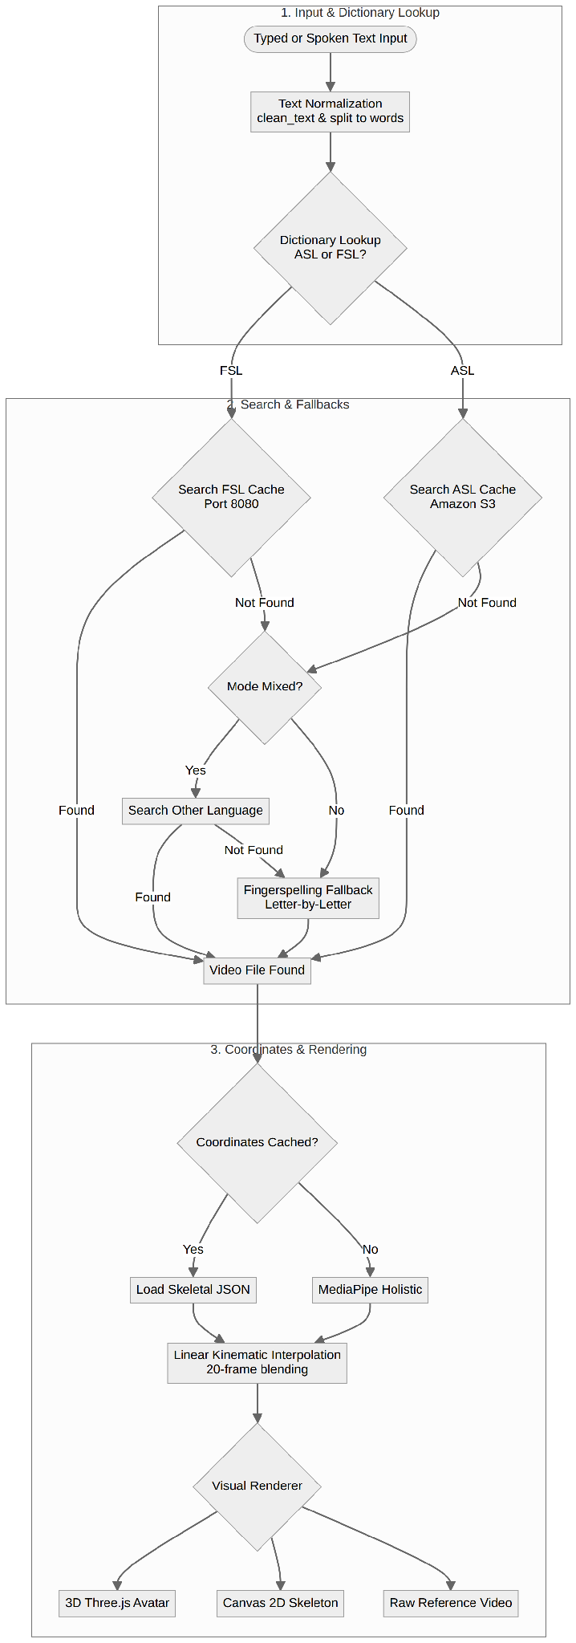
This diagram illustrates the sequential process from spoken language input to the final rendered sign language animation.

2. Signed-to-Spoken Recognition Pipeline
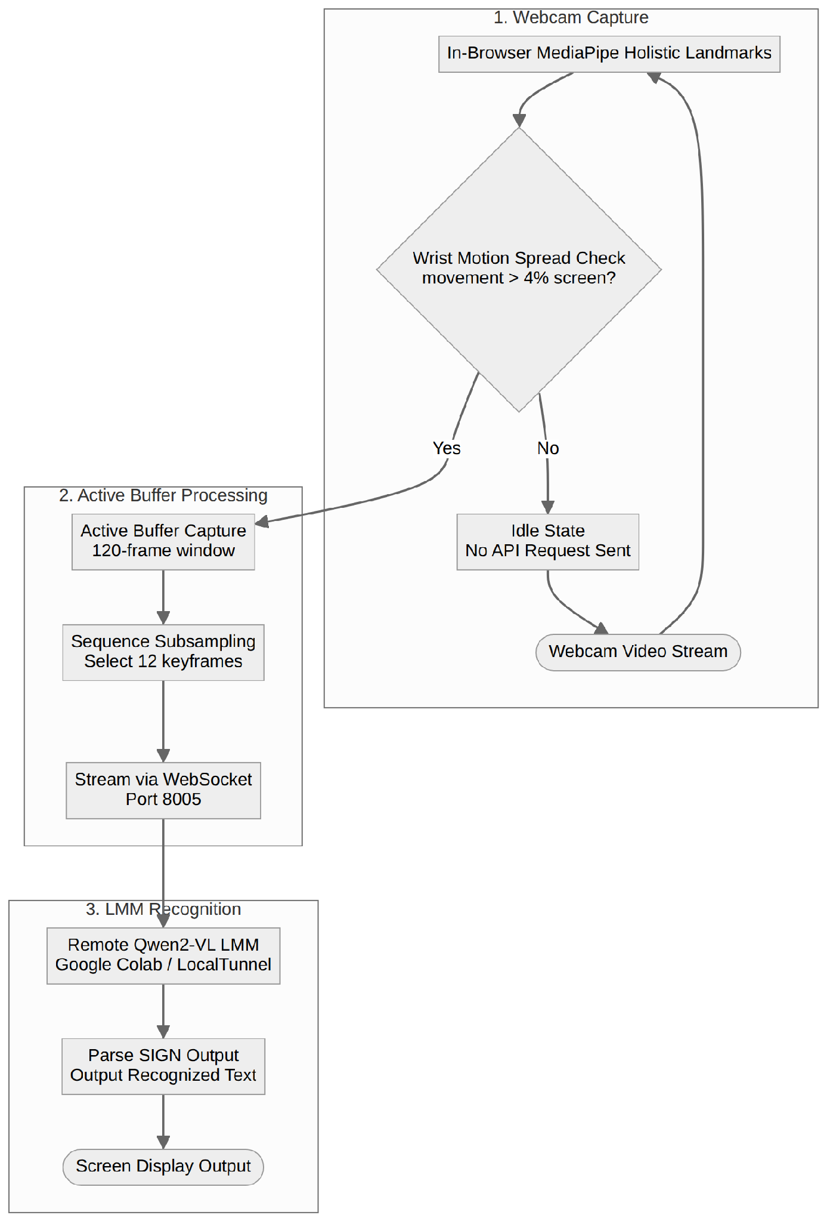
This pipeline processes a video feed of a user signing, tracks landmarks locally, and streams frames over WebSockets to an external Qwen2-VL Large Multimodal Model for text translation.
Figure 2. Proposed Signed-to-Spoken Recognition Pipeline.
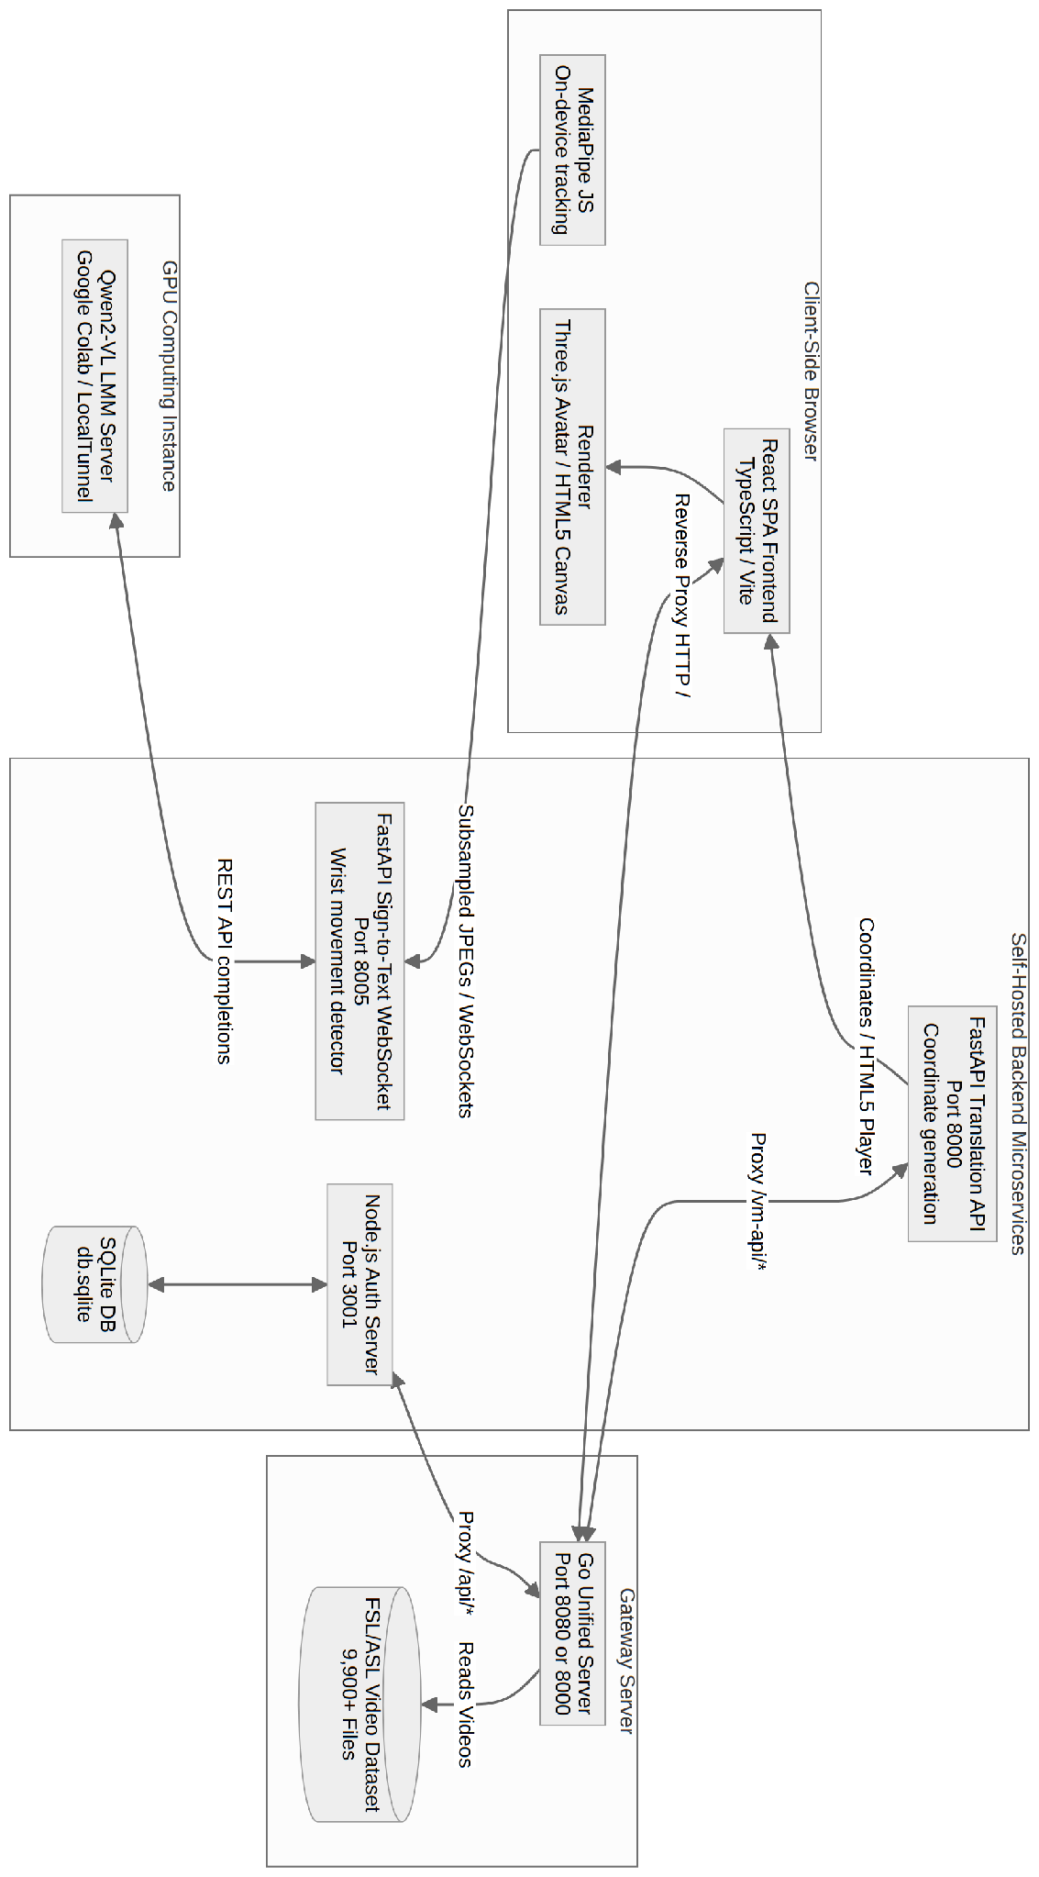
This diagram shows the workflow from capturing a sign language video to outputting the corresponding spoken language text.
The underlying model architecture for recognition is Qwen2-VL, a Large Multimodal Model (LMM). It utilizes Vision Transformers (ViT) to extract spatial features from visual frame sequences, combined with an autoregressive language transformer to decode spatial-temporal representations into coherent translations. It operates as a hosted API server, processing subsampled webcam video frame sequences sent from the client browser. This eliminates the need to train a sequence classifier (such as a custom Transformer or LSTM) from scratch, leveraging zero-shot and few-shot vision capabilities. Dosovitskiy, et al. (2020). which is highly effective for multimodal tasks. It uses separate, specialized encoders for different data streams and projects them into a shared "latent" space. This combined representation is then processed through a central, powerful transformer model that can learn complex relationships between the different modalities. Finally, small, efficient decoders translate this processed representation into the desired output. This architecture allows the model to learn rich, interconnected features from different types of input simultaneously, making it ideal for the complex task of sign language translation.

Figure 3. System Architecture Overview.
The system architecture coordinates real-time data flows between the user's web interface, the gateway proxy, and hosted backend microservices.
Proposed Evaluation Metrics and Performance Targets
To validate the system's viability, we will use a set of quantifiable metrics inspired by state-of-the-art research in the field.
- Word Error Rate (WER): The primary metric for recognition accuracy.
$WER = \frac{S + D + I}{N}$
Where S is the number of substitutions, D is deletions, I is insertions, and N is the total number of words in the reference.
- User-Rated Clarity Score: A qualitative measure of production clarity, evaluated on a 5-point Likert scale by fluent signers.
- End-to-End Latency: The time from input to output, critical for real-time conversation.
$Latency = T_end - T_start$
The performance targets for these metrics are summarized in the table below.
Metric | Target | Description
Accuracy (WER) | < 15% | The Word Error Rate on a holdout test set combining both FSL and WLASL data.
Clarity Score | ≥ 4.0 / 5.0 | Average user rating on the clarity of the 3D avatar for FSL signs.
Latency | < 750 ms | Average end-to-end time for a full translation.

Methodology of Evaluation:
- Quantitative Analysis
The Word Error Rate (WER) and latency will be measured by running a curated test set of pre-recorded FSL and ASL video clips through the recognition pipeline. The system's output will be compared against ground-truth transcriptions. Latency will be programmatically measured across 100+ trials to calculate a stable average.
- Qualitative Analysis
A user study will be conducted with a cohort of at least 10 participants from the Filipino deaf community and fluent FSL signers. Participants will be asked to perform specific tasks and rate the clarity of signs generated by the 3D avatar on a 5-point Likert scale. Feedback on the user experience will also be collected through structured interviews.

Scope and Limitations of the Study
This study focuses on the design, development, and evaluation of a proof-of-concept system. The scope is defined by the following boundaries, which also highlight the project's limitations:
- Vocabulary Scope: The system's vocabulary is limited to the indexed FSL video files (sourced from Iglesia ni Cristo) and Pocket Sign ASL datasets. It does not cover the entire lexicon of either language, but it falls back to fingerspelling (letter-by-letter lookup) when a word is not found. It will not cover the entire lexicon of either language.
- Grammatical Complexity: The initial version will not capture the full grammatical complexity of sign language. Essential non-manual markers, such as nuanced facial expressions for tone and questions, and the use of signing space for spatial grammar, are not explicitly modeled in this phase.
- Focus on Individual Signs: The recognition model will primarily focus on word-level or short-phrase recognition rather than continuous, conversational translation, which remains a significant long-term research challenge.
- Rendering Realism: The Human GAN feature, while a goal, is a significant technical challenge for real-time performance and may not be fully optimized in the initial prototype.
Future work will aim to address these limitations by expanding the datasets, incorporating more advanced grammatical models, and optimizing the rendering pipelines.

Definition of Terms
For clarity, the following key terms are defined as they are used in this study:
- FSL (Filipino Sign Language): The national sign language of the Filipino deaf community.
- MediaPipe: A Google framework for building multimodal machine learning pipelines, used for real-time pose, hand, and face landmark detection from video. (Ba Alawi, Z. (2025).
- WLASL (Word-Level American Sign Language): A large-scale video reference dataset for ASL signs, used in this project as the visual database for American Sign Language reference videos. (Li, et al., 2020).
- WER (Word Error Rate): A standard metric for measuring the accuracy of a speech or sign recognition system by calculating the number of errors (substitutions, deletions, insertions) in the transcribed text. (Rastgoo, et al. 2020, Camgoz, et al. 2020).
- Transformer: A deep learning architecture based on self-attention mechanisms, highly effective for processing sequential data like language and video. (Vaswani, et al., 2017).

CHAPTER 2

REVIEW OF RELATED LITERATURE AND STUDIES

This chapter provides a discussion of the past studies, foundational principles, and technological advancements that are relevant to this paper. The review is organized thematically to cover the core components of the proposed system: the evolution of sign language translation, the rise of the Transformer architecture, the role of real-time pose estimation, the use of modern web technologies for deployment, and the specific need for Filipino Sign Language resources.

The Evolution of Sign Language Translation Systems
The automated translation of sign language is a long-standing challenge in computer science. Early research focused on sensor-based methods, such as data gloves, which could achieve high accuracy but were impractical for everyday use due to their intrusive and costly nature. With the rise of computer vision, research shifted towards camera-based recognition.
Initial vision-based systems often relied on traditional machine learning techniques applied to hand-crafted features. However, the true breakthrough came with the advent of deep learning. Architectures like Convolutional Neural Networks (CNNs) for spatial feature extraction and Recurrent Neural Networks (RNNs) or Long Short-Term Memory (LSTM) networks for temporal analysis became the standard for video-based sign language recognition.
A significant body of work, exemplified by the creation of the WLASL (Word-Level American Sign Language) dataset (Li, et al., 2020), has focused on "isolated sign recognition," where models are trained to classify individual signs. While successful, this approach does not address the complexities of continuous, conversational sign language. More recent studies aim to tackle this by developing models that can process unsegmented video streams, a challenge that requires more advanced architectures.

The Rise of Transformer Models in Language and Vision
The introduction of the Transformer architecture by Vaswani, et al. (2017) revolutionized the field of natural language processing and has since been adapted for numerous other domains. Its core innovation, the self-attention mechanism, allows a model to weigh the importance of different parts of the input data, making it exceptionally powerful at understanding context and long-range dependencies in sequences.
This power was not limited to text. The paper "An Image is Worth 16x16 Words" (Dosovitskiy, et al., 2020) introduced the Vision Transformer (ViT), which demonstrated that a pure Transformer architecture could outperform state-of-the-art CNNs on image classification tasks. This established Transformers as a dominant architecture for visual data.
Consequently, researchers began applying this to the domain of sign language. Studies such as "Sign Language Transformers" (Camgoz, et al., 2020) have shown that Transformer-based models are highly effective for both word-level and sentence-level sign language recognition, as they can effectively model the complex spatio-temporal relationships of sign movements. The use of Large Multimodal Models (LMMs) like Qwen2-VL, which this project utilizes, is a direct evolution of this paradigm.
Real-Time Pose Estimation as a Foundational Layer
A major challenge in sign language recognition is efficiently processing high-resolution video data. Instead of feeding raw pixels into a model, a more effective approach is to first extract the key skeletal points of the person signing. This is where real-time pose estimation frameworks have become critical.
MediaPipe, a framework developed by Google (Lugaresi, et al., 2019), provides a suite of incredibly fast and accurate models for this purpose. Specifically, its Holistic solution can detect 543 landmarks across the body, face, and hands simultaneously from a single video frame. By using MediaPipe as a preprocessing step, a video stream is converted into a lightweight time-series of coordinate data. This has two key advantages:
- Efficiency: The main translation model processes a much smaller amount of data, enabling real-time performance even in a web browser.
- Privacy: The raw video can be processed entirely on the client's device, and only the anonymized skeletal data needs to be used for inference, enhancing user privacy.
This approach of separating pose estimation from the core translation task is a common and effective strategy in modern sign language recognition systems.

Web Technologies for Accessible and Scalable Deployment
A key limitation of past research is that many powerful systems were confined to the laboratory. The goal of this project is to create a publicly accessible tool, which is made possible by modern web and cloud technologies.
- 1. Self-Hosted API Microservices (FastAPI & Go): Instead of utilizing serverless cloud functions (which experience cold starts and runtime limits), the backend is structured as lightweight, containerized microservices hosted on virtual server instances. FastAPI handles fast coordinate math and Python routines, and a Go server handles high-throughput video delivery. This self-hosted model provides direct control over computing resource allocations (such as swap memory configuration).
- 2. React Frontend Framework: Built using React 18, Vite, and TypeScript. By developing layout rules natively via custom responsive vanilla CSS, the system maintains desktop and mobile viewport flexibility and modular transitions without the structural overhead of third-party mobile wrapper frameworks.
- 3. Relational Local Database (SQLite): User profiles, verification records, and user stats are managed locally in a SQLite instance (using Express.js on Port 3001). This removes dependency on remote cloud databases like Firestore and guarantees low database query latency.

Local Studies and Developments in FSL Technology
In recent years, there has been a notable increase in research and development within the Philippines focused on applying modern technology to Filipino Sign Language (FSL). This local work provides important context and highlights the specific challenges and opportunities in the field.
A recurring theme in local research is the focus on static gesture recognition, particularly for the FSL alphabet and numbers. A 2022 study, for example, utilized a Convolutional Neural Network (CNN) based on the ResNet architecture to recognize Filipino number signs (0-9) from static images, achieving a respectable validation accuracy of 86.7%. This demonstrates the viability of deep learning for FSL but also underscores the limitation to a small, static subset of the language.
More recent studies have begun to tackle dynamic gestures and phrases. A 2024 paper from researchers at the University of San Jose-Recoletos detailed a system for recognizing 3 basic words and 27 phrases in FSL. Their method successfully used MediaPipe to extract hand features from a webcam feed and an LSTM (Long Short-Term Memory) algorithm for classification, achieving a high testing accuracy of 98.89%. Similarly, another 2024 study from the University of San Carlos combined CNN and LSTM models to recognize 10 common expressions and five transactional inquiries in real-time, reporting a 98% accuracy rate and noting a significant improvement over previous systems.
These studies are significant as they validate the use of the same core technologies proposed in this paper—MediaPipe and deep learning models like LSTMs—for the FSL context. However, they also clearly define the existing research gap: these projects are primarily one-way recognition systems (signed-to-text) and are often limited to a small, predefined set of words or phrases rather than a scalable, bidirectional conversational tool. This highlights the novelty and necessity of the full-stack, bidirectional system proposed in this thesis.

The Need for Localized FSL Resources and Transfer Learning
While the technologies above are universal, their application must be localized to be truly effective. The vast majority of high-quality, large-scale datasets are for American Sign Language. This presents a major gap for the Filipino context.
This project addresses this gap by employing Transfer Learning, a technique where a model pre-trained on a large dataset is fine-tuned on a smaller, more specific dataset. The availability of the FSL Dataset on Kaggle (Porton, 2021), containing images of the Filipino Sign Language alphabet, provides the crucial resource for this process. By fine-tuning a model already powerful at understanding the general dynamics of sign language (from WLASL), we can create an accurate FSL recognition model far more efficiently than training one from scratch.

Synthesis of Review of Related Literature and Studies
The reviewed literature confirms several key points. First, the Transformer architecture is the current state-of-the-art for sequence-based tasks, including sign language translation. Second, client-side pose estimation with tools like MediaPipe is a proven and efficient method for processing real-time video for this task. Third, modern web technologies like React, Vite, and self-hosted microservices (FastAPI, Go) provide a clear and viable path for building and deploying a scalable, accessible application.
However, the review also highlights a clear and significant research gap. As noted in the field, the research landscape for sign language translation is often fragmented, with different research groups focusing on isolated components of the translation pipeline (e.g., only recognition, only production, or only a specific language) without integrating them into a cohesive, end-to-end system.
This study synthesizes these state-of-the-art components—a Transformer-based ML model, a real-time pose estimation pipeline, and a modern full-stack web architecture—and applies them to the underserved domain of Filipino Sign Language. The novelty of this project lies in its holistic, full-stack integration, creating a single, modular, and open platform that handles bidirectional translation. By using transfer learning to bridge the data gap, this project aims to fill the identified research gap and make a novel and significant contribution to accessible communication technology in the Philippines.

CHAPTER 3

RESEARCH METHODOLOGY

This section outlines the research methods that will be used to carry out the study. These methods include the research design, development methodology, population and sampling strategies, research instruments, and the procedures for data gathering and statistical analysis.

Research Design: The Design and Development Research (DDR) Framework
This study will employ a Design and Development Research (DDR) framework as its core research design. This paradigm is the most appropriate structural choice because the study's primary objective is to address a clear, real-world operational challenge: the fragmented and often inaccessible nature of sign language communication. This problem cannot be solved by purely descriptive or explanatory research; instead, it requires the systematic creation and empirical validation of an innovative technological artifact—the bidirectional sign language translation system.
The DDR framework organizes the research cycle into three distinct phases, as illustrated in Figure 4, ensuring a structured progression from problem identification to solution validation.

Figure 4. Design and Development Research (DDR) Framework Cycle
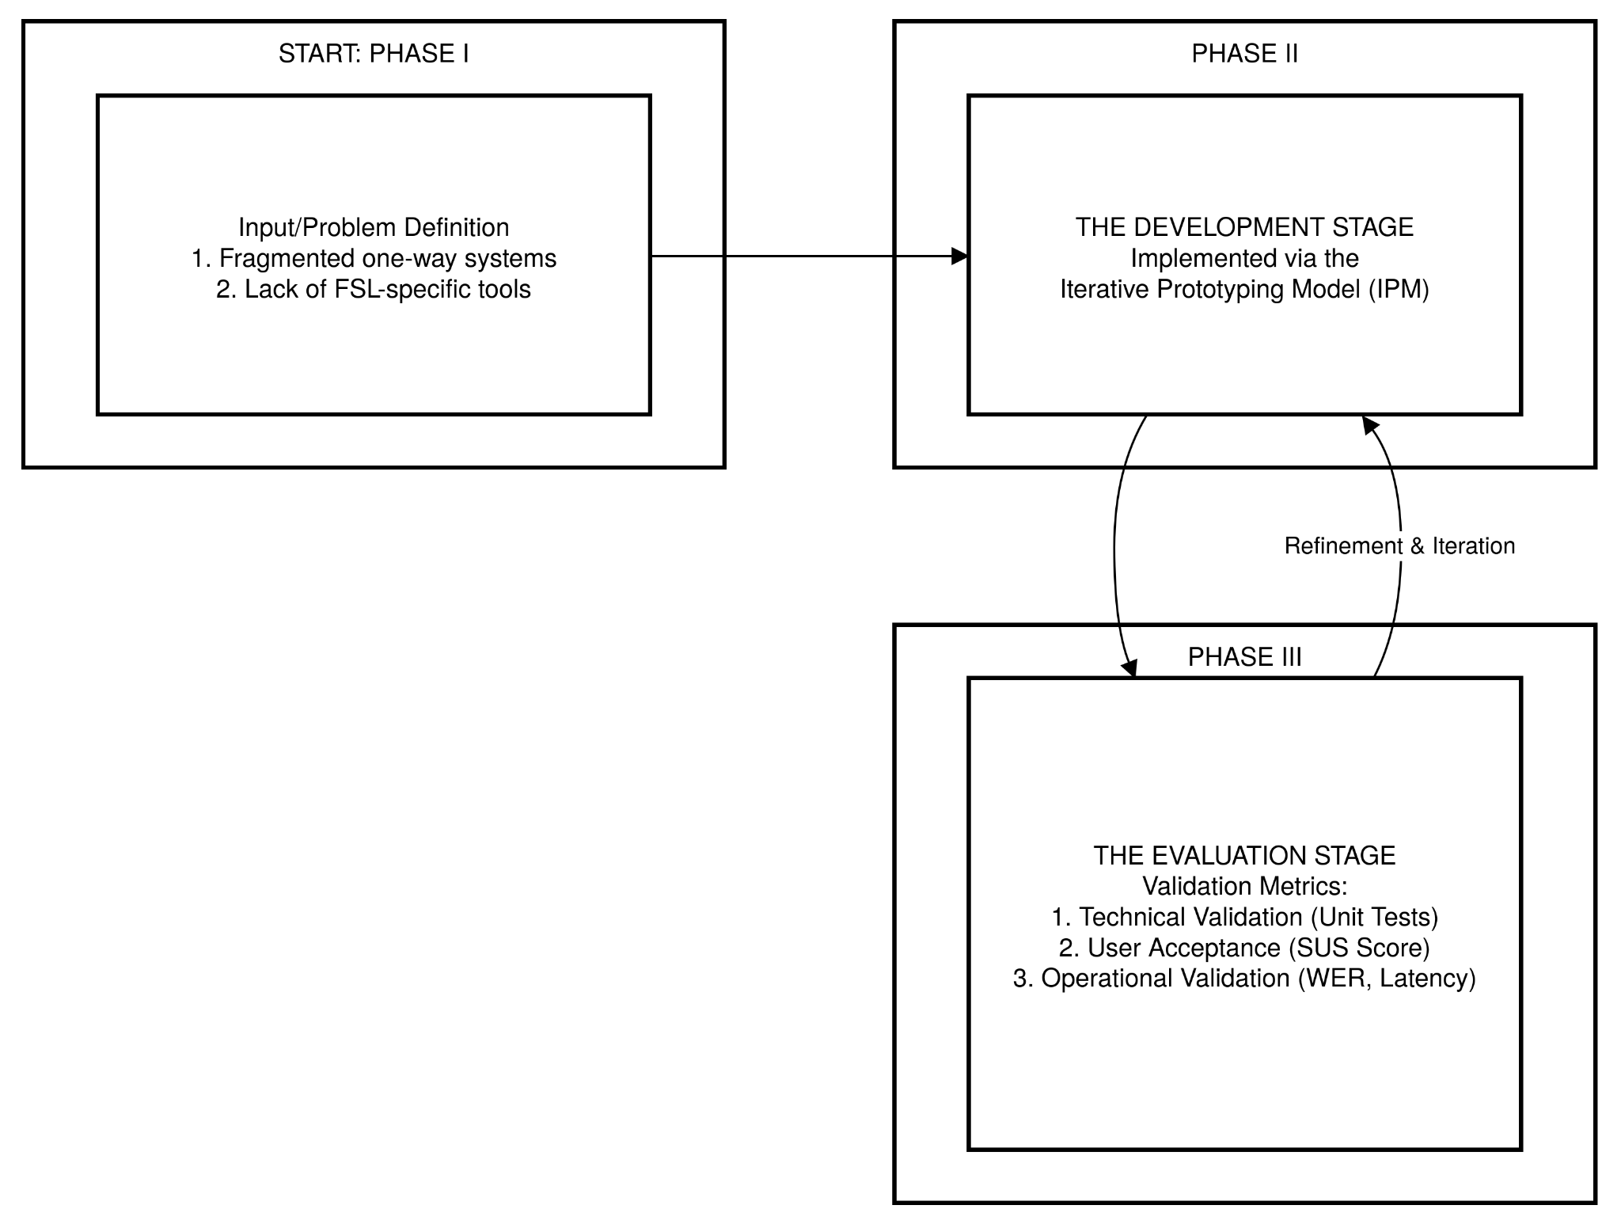

As applied to this study, the cycle begins with Phase I: Input/Problem Definition, where the shortcomings of existing communication tools are defined, including the lack of bidirectional systems and the reliance on ASL-centric models. The research then proceeds to Phase II: The Development Stage, where the full-stack, bilingual (FSL/ASL) translation system is methodically constructed using the Iterative Prototyping Model. The process concludes with Phase III: The Evaluation Stage, where the functional artifact undergoes a rigorous post-implementation evaluation to verify its effectiveness against the performance metrics defined in Chapter 1.
A key methodological requirement of the DDR paradigm is holistic validation across three critical domains:
- Technical Validation: This will be achieved through systematic unit and regression testing to ensure the core algorithms, API integrations (MediaPipe, Node Express endpoints, SQLite queries), and data pipelines function as intended.
- User Acceptance Validation: This will be measured using the Technology Acceptance Model (TAM), with the System Usability Scale (SUS) as the primary instrument to quantify the system's Perceived Ease of Use (PEOU).
- Operational Validation: This is the most crucial domain for DDR, as it requires objective evidence of the system's Perceived Usefulness (PU). This will be determined empirically by measuring the system's performance against the predefined targets for Word Error Rate (WER) and End-to-End Latency.

Development Methodology: The Iterative Prototyping Model (IPM)
The Development Stage (Phase II) of the DDR framework will be implemented using the Iterative Prototyping Model (IPM). This model is exceptionally well-suited for this project due to its inherent complexity, the need to integrate multiple technologies, and the requirement for continuous refinement based on both technical and user feedback. Rapid, cyclical development and testing are essential for a system involving real-time machine learning and a cross-platform user interface.

Figure 5. Iterative Prototyping Model (IPM) Implementation Cycle
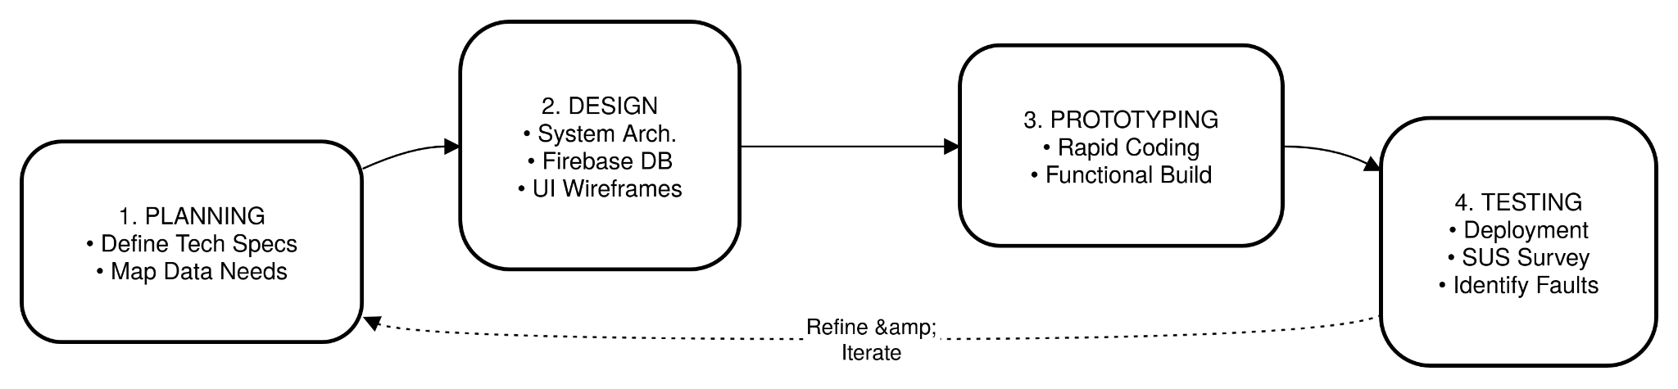
The IPM consists of four stages that are repeated in cycles:
- Requirements Gathering and Planning: This initial phase involves defining the technical requirements for both the Spoken-to-Signed and Signed-to-Spoken pipelines, mapping the data flow, and analyzing the architectural needs.
- Design: This stage focuses on creating the system architecture, defining the database schema (using embedded SQLite for relational local data), and specifying the user interfaces for the web and mobile applications.
- Prototyping: This involves the rapid construction of functional versions of the system, starting with core functionalities and iteratively adding features.
- Testing and Feedback Collection: Each prototype is deployed to select user groups to gather usability data and identify faults or areas for improvement, which then informs the next iteration.

Population and Sample Size
The target population for this study comprises three distinct groups to ensure a holistic evaluation of the system's bidirectional capabilities. A total of 50 participants will be selected to participate in the testing and evaluation phases.
- Cohort A: Deaf and Hard-of-Hearing Individuals (n=15): This group represents the primary beneficiaries. They will evaluate the accuracy of the Spoken-to-Signed (Avatar) feature and the system's ability to recognize their natural FSL signing.
- Cohort B: FSL Interpreters and Educators (n=5): Subject matter experts who will validate the linguistic accuracy of the translations and the correctness of the SignWriting conversion.
- Cohort C: General Public/Non-Signers (n=30): Hearing individuals with little to no knowledge of sign language. They will evaluate the Signed-to-Spoken feature and the overall usability (UI/UX) of the web application.

Sampling Technique
The study will utilize Purposive Sampling for Cohorts A and B. This non-probability sampling technique is necessary because these participants must possess specific characteristics (fluency in FSL and lived experience as a Deaf individual or interpreter) to provide valid feedback on the translation accuracy.
For Cohort C (General Public), Convenience Sampling will be employed to recruit participants who have access to standard web devices (smartphones or laptops) to test the system's accessibility and performance in real-world scenarios.

Research Approach: A Mixed-Methods Strategy
To satisfy the holistic validation requirement of the DDR framework, this study will adopt a mixed-methods approach. This methodology incorporates both quantitative measurement of performance outcomes and qualitative diagnosis of the user experience, ensuring that the analysis provides both quantified evidence of the system's effectiveness and a contextual understanding of its usability.
- The Quantitative Domain is deployed to objectively measure system performance and acceptance. This includes automatically logged metrics (WER and latency) and standardized subjective data collected through the System Usability Scale (SUS). This domain answers the empirical questions of "how accurate" and "how fast" the system is, and "what" the final perception of its usability is.
- The Qualitative Domain provides essential diagnostic depth to understand the underlying reasons for the quantitative results. This involves pre-system interviews to establish baseline user expectations and post-test semi-structured interviews to diagnose specific points of failure or success in the user experience.

Data Gathering Procedure
The data collection will proceed in three phases:
- Pre-Testing & Calibration:
  - The system's recognition model will first be benchmarked internally using the FSL Dataset to establish a baseline Word Error Rate (WER).
- Controlled Deployment:
  - Participants will be given specific tasks (e.g., "Sign the word 'Hello'", "Translate this phrase").
  - For Quantitative Data: The system will automatically log the End-to-End Latency (in ms) for every translation request and compare the output against a ground-truth script to calculate WER.
  - For Qualitative Data: After completing the tasks, participants will answer the System Usability Scale (SUS) questionnaire.
- Post-Test Interviews:
  - Semi-structured interviews will be conducted with selected participants from Cohort A to gather deep insights into the "naturalness" of the 3D Avatar's movements.
Table 1. Alignment of Research Frameworks, Objectives, and Metrics
Research Framework/Stage | Core Objective | Evaluation Metric/Instrument | Validation Type
DDR (Development) | Construct the translation system via IPM. | Functionality Checklists (Unit/Regression Testing) | Technical
TAM (PEOU) | Verify interface simplicity and intuitiveness. | System Usability Scale (SUS) Score (0-100) | Subjective
TAM (PU) | Quantify improvement in communication capability. | Word Error Rate (WER) & End-to-End Latency Logs | Objective

Statistical Treatment of Data
To interpret the data effectively, the following statistical tools will be used:
1. Weighted Mean:
This will be used to analyze the Likert scale responses regarding the clarity of the 3D Avatar.
$xˉ=∑fxnxˉ=n∑fx​$
Where:
- $xˉ$= Weighted Mean
- $f$ = Frequency of each option
- $x$ = Weight of each option
- $n$ = Total number of respondents
2. System Usability Scale (SUS) Scoring:
To process the usability survey data, the standard SUS scoring formula will be applied.
- For odd-numbered items (1, 3, 5...): Score = User Response - 1
- For even-numbered items (2, 4, 6...): Score = 5 - User Response
Total SUS Score = (Sum of all converted scores) × 2.5
3. Interpretation of Likert Scale:
The user feedback will be interpreted using the following range:
Scale | Range | Verbal Interpretation
5 | 4.20 – 5.00 | Strongly Agree / Excellent Clarity
4 | 3.40 – 4.19 | Agree / Good Clarity
3 | 2.60 – 3.39 | Neutral / Average Clarity
2 | 1.80 – 2.59 | Disagree / Poor Clarity
1 | 1.00 – 1.79 | Strongly Disagree / No Clarity

REFERENCES:
Pilare, L. K. M., et al. (2024). Filipino Sign Language Hand Gesture Recognition Using MediaPipe and Machine Learning. International Journal of Computing Sciences Research, 8, 3252-3267.
Rivera, J. C., & Ong, E. C. (2024). Gesture Recognition of Filipino Sign Language Using Convolutional and Long Short-Term Memory Deep Neural Networks. Knowledge, 4(3), 358-381.
Ba Alawi, Z. (2025). A Comparative Survey of PyTorch vs TensorFlow for Deep Learning: Usability, Performance, and Deployment Trade-offs. arXiv preprint arXiv:2508.04035.
Camgoz, N. C., et al. (2020). Sign Language Transformers: A New Architecture for Word and Sentence-level Sign Language Recognition. arXiv preprint arXiv:2004.09101.
Azeroual, O., Schöpfel, J., & Saake, G. (2021). Implementation and user acceptance of research information systems. arXiv preprint arXiv:2111.08309.
Ma, J., & Casella, A. (2025). Integrating Transparent Models, LLMs, and Practitioner-in-the-Loop: A Case of Nonprofit Program Evaluation. arXiv preprint arXiv:2510.19799.
Dosovitskiy, A., et al. (2020). An Image is Worth 16x16 Words: Transformers for Image Recognition at Scale. arXiv preprint arXiv:2010.11929.
Vite.js Documentation. Retrieved from https://vite.dev
React.js Documentation. Retrieved from https://react.dev
FastAPI Framework Documentation. Retrieved from https://fastapi.tiangolo.com
Go Programming Language & Gin Gonic Framework. Retrieved from https://gin-gonic.com
Li, D., et al. (2020). WLASL: A Large-Scale Word-Level American Sign Language Video Dataset. arXiv preprint arXiv:1910.11006.
Nikitin, N., & Fomin, E. (2025). Developing Lightweight DNN Models With Limited Data For Real-Time Sign Language Recognition. arXiv preprint arXiv:2507.00248.
Huang, C., Tashi, N., Gao, F., Liu, Y., Li, J., Tian, H., Jiang, S., Tsering, T., Ma-bao, B., Duojie, R., Luosang, G., Dongrub, R., Tashi, D., Zhang, J., Feng, X., Wang, H., Tang, J., Tang, G., Wang, X., Zhang, J., Lee, T., & Yu, Y. (2025). Tibetan Language and AI: A Comprehensive Survey of Resources, Methods and Challenges. arXiv preprint arXiv:2510.19144.
Philippine Statistics Authority. (2023, January 26). Functional Difficulty in the Philippines: For Household Population Five Years Old and Over (2020 Census of Population and Housing). Retrieved from https://psa.gov.ph/content/functional-difficulty-philippines-household-population-five-years-old-and-over-2020-census
Porton, J. (2021). FSL Dataset. Kaggle. Retrieved from https://www.kaggle.com/datasets/japorton/fsl-dataset
Rastgoo, R., et al. (2020). Sign Language Recognition: A Deep Survey. arXiv preprint arXiv:2008.06457.
Formont, P., Darrin, M., Karimian, B., Cheung, J. C. K., Granger, E., Ayed, I. B., Shateri, M., & Piantanida, P. (2025). Learning Task-Agnostic Representations through Multi-Teacher Distillation. arXiv preprint arXiv:2510.18680.
Boháček, M., & Hrúz, M. (2022). Sign Pose-Based Transformer for Word-Level Sign Language Recognition. arXiv preprint arXiv:2208.12148.
Jiang, S., et al. (2024). SignLLM: Sign Language Production via Large Language Models. arXiv preprint arXiv:2401.08889.
Moryossef, A., et al. (2021). Data Augmentation for Sign Language Gloss Translation. arXiv preprint arXiv:2105.07493.
Saunders, B., Camgoz, N. C., & Bowden, R. (2020). Progressive Transformers for End-to-End Sign Language Production. arXiv preprint arXiv:2004.14874.
Tunga, A., Nuthalapati, S. V., & Wachs, J. P. (2021). Pose-based Sign Language Recognition using GCN and Transformer. arXiv preprint arXiv:2110.03930.

